# Hackthon Day 7

# Live Deployment And Post-Launch Practices

# Environment Variable Security Configure

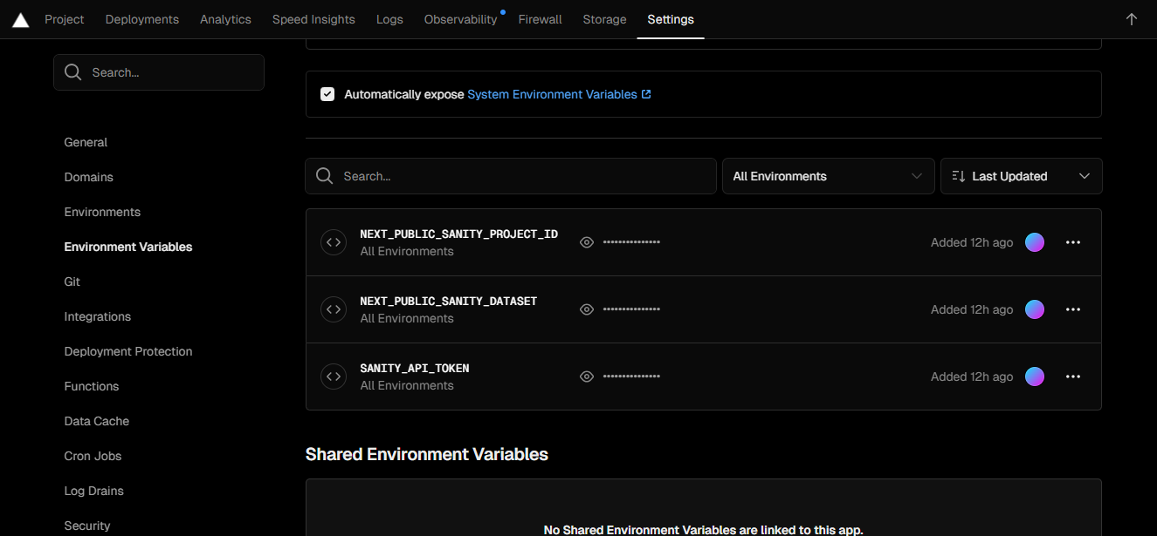

# Vercel Link

# SSL aur Https Enable

<https://vercel.com/zainub-nazishs-projects/zainub-template-four-wumv>